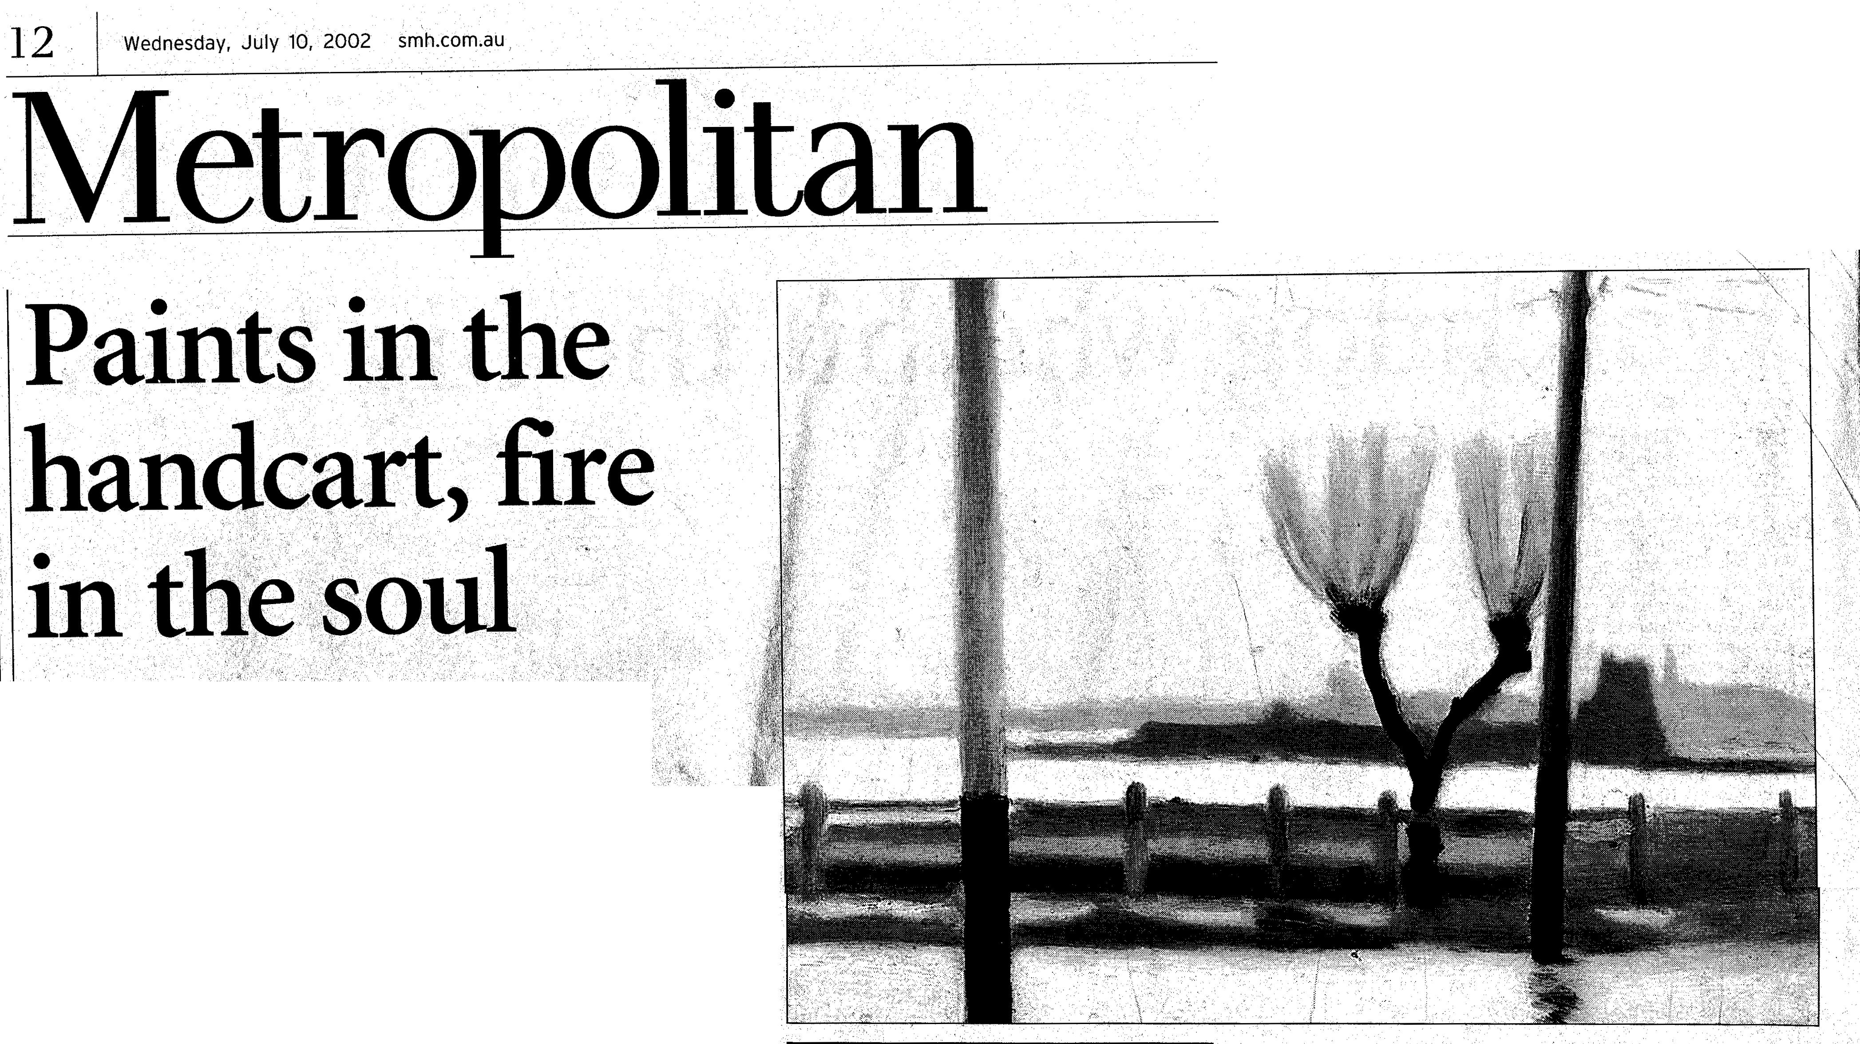***It's startling how*** *modern the paintings of Glance Beckett* ***— who died in*** *1935 — look writes Bruce J****ames.***

Clarice Beckett's *Bathing Boxes After Storm,* 1934, is the except­ion that proves the rule, an image of disorder in the work of **Aust ralian** art's most orderly painter. but thrilling exhibition at Martin Browne Fine Art is the identically sized *Boatsheds in the Storm,* showing the same gale before it caused any damage, the edgier *Bathing Boxes After Storm*

**.CLARICE BECKETT**

* Born 1887 in Casterton, Victoria. **Studied at** the

NationalGallery School in Melbourne from 1914 to 1916

and then under Max Meldrum from 1917. While caring for

elderly patients at Beaumaris she painted mostly in the early morning or evening, pushing a handcart filled with

her painting materials.

* Held a series of reasonably successful exhibitions,

mainly at the Athenaeum Gallery, Melbourne.

* Died on July 6, 1935, as a result of pneumonia
* Posthumous fame grew in the 1970s and '80s,

especially through the efforts of her champion, Rosalind Hollinrake. A major retrospective, Clarice *Beckett: Politically Incorrect,* toured Australia in

* Prices in current exhibition range from .$10,000 to $65,000.



focuses on the jumbled wreckage of wind and wave. Beckett must have looked askance at the disarray, thinking what a poor account it gave of nature and what a sorry prospect it offered for painting.

She painted it nonetheless, in with a vengeance. Why? What appealed to Beckett in the ticky­tacky aftermath of a mild disaster which the civic-minded inhabi tants of Beaumaris probably set to rights in an afternoon?

One is tempted to discern a hint of petulance in the handling, noticeably scruffier than normal, and more abbreviating - if that's possible in a painter who prac tised shorthand from the day she took up the brush and whose mentor, Max Meldrum, advised his followers to blur their pictorial tones by squinting while they painted. Maybe Beckett was simply out of sorts - with herself, her home life, a brutish lover, who knows? - and something in the bereftness of the setting, despite its inconsequentiality in the grander scheme, struck a chord with her. Whatever the case, she was dead within months of finishing *Bathing Boxes After Storm,* a casualty of double pneu­monia, exhaustion and, as some suggest, a broken heart. The pneumonia resulted from a chill Beckett caught while painting in a storm.

This storm? It's not an offensive question to ask. So rarely is

Beckett's work tempestuous in either topic or treatment, the panel draws attention to itself in the manner of a blatant clue, or a cry for help. In Christian thinking, storm-tossed boat. Just as cred­ibly, couldn't it be a battered bathing box? T. S. Eliot's rag-and-bone shop of the heart was the supreme symbol of spiritual derel­iction in the interwar period in the West There's no evidence that Beckett admired the author ofA *Waste Land,* but anyone familiar with her work will recognise her bathing boxes for what they are receptacles for profoundly inti­mate feelings, rag-and-bone shops where she kept a private store of memory, desire, anger and disap­pointment To watch one toppled omits side, as we do here, others listing perilously, is to witness a forecast of the artist's annihil­ation, staged in terms of an ordinary suburban beachscape.

Bathing boxes were not the only personal signifiers in her art. Beckett invested herself prolifi­cally in power poles, street lights, motor cars, petrol pumps and trams, an effectively modern­ist inventory of 20th-century industrial hardware which Eliot also chose to foreground in his work. There's an electric hum beneath every one of Beckett's paintings. Even the most wishy-washy of her Whistlerian nocturnes and Corot-esque poesies give off a terrific charge. It is why we bother with her at all. Without it, she would pass another jobbing Meldrumite with a minor talent for ellipsis. T e lack of surface drama in h paintings - and even the st images avoid obvious signs of tumult - is deceptive, since it can lead one to make the assumption that they are undramatic at it core.

The reverse is true. Becke

Electric hum .. Beckett's Wet~ *Evening,* 1927, could easily be

dated 1997.

1999-2000.

e painter of the galvanic

oment, which she sets for the wer to discover, deep and nt, in her images. On first ht, her works underwhelm. ey appear timid. Tentative. Bland. But longer viewing allows

their little die-cast engines to   
grind into action. There is often :a shocking moment of realisation when looking at a Clarice Beckett that causes all one's prejudices about pleasant landscapes and pretty sea paintings to go up in smoke. Her paintings are hot stuff. In the face of their coolness of execution and tone, they burn.

contracted while painting outdoors.

Martin Browne's several important exhibits bear out this

phenomenon, none more deliquescently than *Boats on the Yarra* and *Last Tram.* Painted in the same year, 1931, and accord­ing to similar compositional strategies, these examples of Beckett's mastery are hung as pendants, and should be. One is a river subject, the other a street scene, but night, wetness and the artist's fiery dissolutions collude to rob them of their outward materiality, The street becomes a simmering puddle, the stretch of Yarra a bituminous quagmire. The air itself thickens in the mutual exchange that takes place between liquids and solids so that the antiquated word gloaming

can be applied with conviction to the resulting atmospheric conditions. It's startling how modern Beckett is, how fresh her pictures look.. Wet *Evening* and *Mordialloc Pier (The Petrol Pump) , are* dated 1927, but 1997 would equally convince. While *Bus Stop,* ***Beach*** *Road arid Sunset, also* 1927, could be a slightly neglected municipal back road almost anywhere today, that favourite shortcut, still unsurfaced, to Sunday barbecues in the sand.

Even the ModelTs are begin-n ng to resemble certain late-release 4WDs, although **none** of the paintings on this occasion depict cars, and only three of the 28 on show boast human figures. Beckett seems instinctively to have edited out most of the specificities that restrict our enjoyment of urban paintings by Herbert Badham, for example, or Roland Wakelin, to a kind of historical voyeurism, a nostalgia. She streamlined place and time. She essentialised objects. She wiped away any evidence of style, period Style and individual artis­tic style which might have implicated her paintings in their era, or herself for that matter. -Take away the frames, so many of which are either original 1920s mouldings or latter-day pastiches of them, and you have to blink to see that the signature was C. Beckett **and** not that of some

contemporary Victorian tonalist such as Rick Amor or, more 'strikingly, Louise Hearman. Hearman's interest in uncanny situations and mind states can surely trace its pedigree back to Beckett's twilight zone.

This commercial project has travelled from the artist's :home town, which she never left in her lifetime, and was compiled by Niagara Gallery's Bill Nuttall, a well-known champion of her work. Not all of the canvases and panels reach the standard set by *Boats* on *the Yarra* or *Wet Even­ing,* but reserves of Beckett's blazing rarities must be drying up bynow, with many having gone into public collections long ago. The exhibition could be seen to advantage with a couple of other urban-themed shows around town at present. The composite photographic prints of Arthur Wicks at nearby Michael Nagy Gallery in Potts Point compress whole cities into ball-shaped play­things of the gods - beautiful and a bit scary. At a further remove, geographically and spiritually, Ursula Laverty's paintings at the Australian Catholic University Gallery in Strathfield, featuring at least one Parrarnatta Road streetscape topped by celestial visions, give promise of different fire:



Until July 21 (Tuesday-, Sunday) at Martin Browne Fine **Art,** 22 Macleay St, Potts Point.